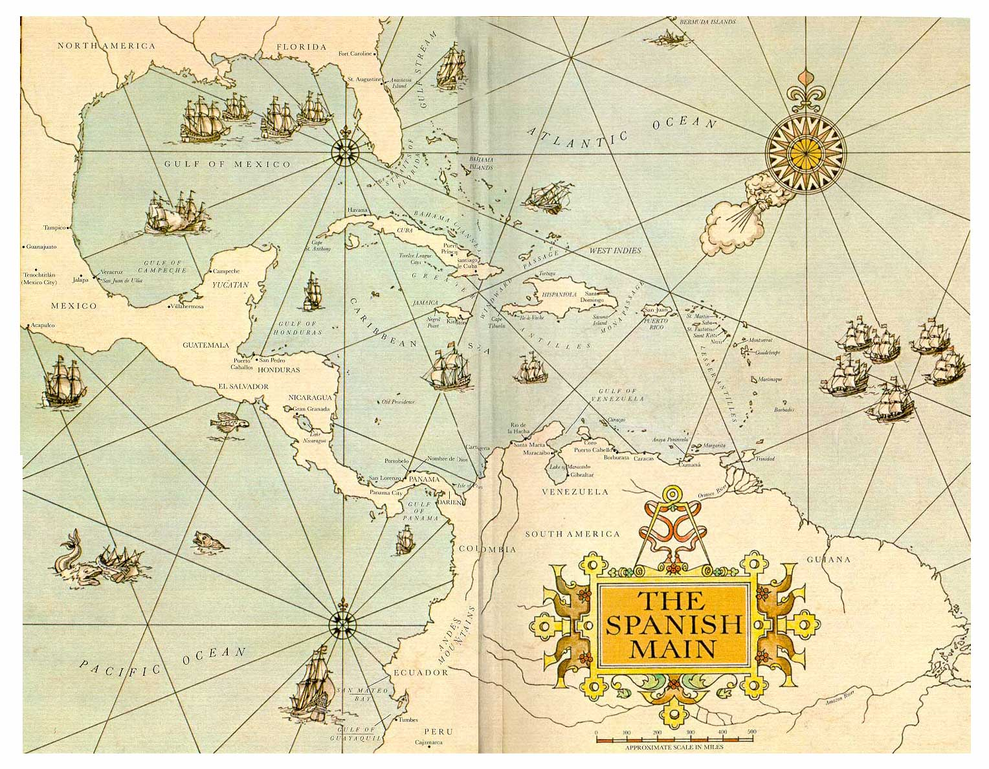

Sails of Santiago

# Table of contents

Contents

[Table of contents 1](#_Toc531343661)

[Project Overview 5](#_Toc531343662)

[Game Overview 5](#_Toc531343663)

[Development Team 5](#_Toc531343664)

[Intended Development Environment 5](#_Toc531343665)

[Risk Analysis 5](#_Toc531343666)

[Project Management 6](#_Toc531343667)

[Evidence of Discord Chat 6](#_Toc531343668)

[Evidence of version control 6](#_Toc531343669)

[Github 6](#_Toc531343670)

[Trello 6](#_Toc531343671)

[Game Design 6](#_Toc531343672)

[Our design 6](#_Toc531343673)

[The Story 6](#_Toc531343674)

[The Theme 7](#_Toc531343675)

[Over world 7](#_Toc531343676)

[Ports 8](#_Toc531343677)

[Living Crew 8](#_Toc531343678)

[Why This Game? 8](#_Toc531343679)

[Game Audience 9](#_Toc531343680)

[Competitor Analysis 9](#_Toc531343681)

[Game Design 10](#_Toc531343682)

[Graphics (concept art sketches) 10](#_Toc531343683)

[Storyboards 11](#_Toc531343684)

[Enemy 11](#_Toc531343685)

[Port 11](#_Toc531343686)

[Menu 12](#_Toc531343687)

[End Game 12](#_Toc531343688)

[Instructions 13](#_Toc531343689)

[Crew/Taverna 13](#_Toc531343690)

[Asset List 13](#_Toc531343691)

[UML 14](#_Toc531343692)

[Ship 14](#_Toc531343693)

[Enemy AI 15](#_Toc531343695)

[Player Artificial Intelligence 16](#_Toc531343696)

[Enemy AI 16](#_Toc531343697)

[Navigation 17](#_Toc531343698)

[Ship Movement/Terrain 17](#_Toc531343699)

[The Ship Movement 17](#_Toc531343700)

[Terrain 17](#_Toc531343701)

[Weather/Wind 17](#_Toc531343702)

[The Weather 17](#_Toc531343703)

[Ship Momentum (Sails > Wind) 18](#_Toc531343704)

[Miscellaneous 18](#_Toc531343705)

[(Map Compass) 18](#_Toc531343706)

[Combat 18](#_Toc531343707)

[Attacking (Game Screen example) 18](#_Toc531343708)

[Health 19](#_Toc531343709)

[HUD (User Interface) 19](#_Toc531343710)

[The HUD 19](#_Toc531343711)

[Audio 19](#_Toc531343712)

[Technical Design 20](#_Toc531343713)

[Platform 20](#_Toc531343714)

[Hardware 20](#_Toc531343715)

[Software 20](#_Toc531343716)

[File Formats 20](#_Toc531343717)

[Development Environment 21](#_Toc531343718)

[Mechanics and Gameplay 21](#_Toc531343719)

[Over world 21](#_Toc531343720)

[Movement 21](#_Toc531343721)

[Accessing Ports 21](#_Toc531343722)

[Combat 21](#_Toc531343723)

[Ports 21](#_Toc531343724)

[Prototype (Demo) 22](#_Toc531343725)

[Critical Appraisals 22](#_Toc531343726)

[Appendices 23](#_Toc531343727)

[Appendix 1 23](#_Toc531343728)

[Discord Chat 23](#_Toc531343729)

[Appendix 2 43](#_Toc531343863)

[Github evidence 43](#_Toc531343864)

[Appendix 3 44](#_Toc531343865)

[Trello evidence 44](#_Toc531343866)

[Appendix 4 45](#_Toc531343867)

[Presentation 45](#_Toc531343868)

[Appendix 5 57](#_Toc531343869)

[List of Assets Used 57](#_Toc531343870)

# Project Overview

## Game Overview

The Sails of Santiago brings the player back to the days during the infamous age of sail – where they can gain wealth and fame through pillaging for both common and exotic booty and defend this said booty from others whom seek to steal these treasures for themselves.

As the player follows in the footsteps of famous known Pirates that sailed the Spanish Main via an open world platform that welcomes exploration with ports that the player can dock their ship to gain supplies through trading, employ new crew, members and do repairs and upgrades to their ship.

A unique feature that we hope to include within our game is a living crew system, which will show how important it is to keeping a balance of a well-trained and happy crew. Which just like the ship they are sailing in, they can obtain damage as well meaning the better trained, happier and healthier crew the player has means better bonuses in the ship’s overall performance.

In effect, our game can be broken into three distinct parts: The over world for combat and navigation, ports for ship management and trading, and crew management.

## Development Team

Gary Malcolmson {B00307865}

Andrew Letailleur {B00334945}

Kirstin Jackson {B00328251}

## Intended Development Environment

The game is, built using the Unity Game Engine (v.2018.2.8.f1), with the use of Visual Studio Community (Edition 2018) for the coding.

All assets will be sourced from the Unity Asset Store or a combination of using Blender or Autodesk’s 3DSMax or Maya to build and either Adobe Photoshop, Paint.net or GIMP to create the textures for any handmade models.

Team communications is, handled through Discord and email, task management through Trello, and version control using Git and GitHub.

## Risk Analysis

Just like any project, there will be risks associated with the overall game idea we have chosen. These risks would be:

* Features not working as expected – As with all game projects, this is one worry that all of the team will be worrying about as new features are, implemented into the code. With the initial design and plans that are described within our documents, this means we need to aim to have our prototype designed early as possible so we can run tests and work out all bugs that might be presented. This will help to make sure that these bugs will not return in the finished project.
* Inexperienced team – The team has experience using other collaboration services such as Github or Google Drive but have had no or little experience using the collaboration services offered through Unity so means that there be risks of crucial assets or scripts being lost while trying to merge the separate projects into one main project.
* Scope – Seeing that the team consists of mainly new developers, the ability to be able to recognize how big the scope of the project will be during the early stages hence making it difficult to judge the requirements of time and effort that will be required over the weeks allotted to make a minimum viable product. Thus, this means early prototyping, many communication and regular updates via meetings to see all progress done will help us with managing if the overall aims we have are reachable or if we need to have a rethink and adjust the project according to this.

# Project Management

Project management in general, went under the Kanban system of task management. With the general responsibilities being assigned to everyone, to manage and break down into smaller tasks.

For checking on status and transfer of files. Discord was, used to distribute tasks to team members. Along with Github and the Unity Cloud service for online storage of the entire project.

Minutes were not taken, as most discussions about the project were, done using Discord. This made meetings obsolete as all talk and ideas were listed for each member on there.

## Evidence of Discord Chat

For evidence of chat on Discord for Sails of Santiago please see Annex’s

## Evidence of version control

### Github

See Appendix 2

### Trello

See Appendix 3

# Game Design

## Our design

The sails of Santiago will be in the style of a 3D game with a third-person, overhead camera.

Our design will consist of three distinct parts: The Over world, Ports, and Living Crew. The latter two sections will seek to break up the game experience and allow the player to develop a playstyle that suits them, within the constraints of the main mechanics of exploration and combat on the Over world.

## The Story

Initially we plan on, running story light, with a general fun pirate feel to the visuals and flavour text. The player will be a Privateer with command of a ship, and make money to keep his crew fed and happy. That is it. Simple, easy to understand, no worrying about whether any mechanical changes will effect a narrative.

This approach will hopefully free us up to focus on gameplay and systems design, which once refined, will give us a strong set of bones from which to hang whatever story we wish.

## The Theme

The romanticised idea of pirates as (mostly) honourable men living without the rules and tyranny of government has many sources of appeal, (frontier living, exploration, adventure, mystery, rebellion and so on), and can encompass all manner of plots and degrees of realism, with supernatural goings on, or even taking them into science fiction and the future. It should be noted that pirates are not always the good guys, typically filling the role of anti-heroes when they are, and a menace when not.

There has been a long running fascination with pirates in media. Tracing its history as far back as the 1800s we begin to see them in novels, initially based on the lives of real men, then over time more fantastical adventures begin to be told, adding elements of the supernatural and fantastic in the forms of curses and hidden treasures.

In the 1930s came Errol Flynn swashbuckling across the seas on film. Also in the 1990's the cartoon series- Pirates of Dark Water, premiered on TV, following the adventures of a young prince named Ren and his crew. Whom sailed the dark waters, to find the thirteen treasures of Rule, without these treasures falling into the hands of the evil pirate lord. Both Iterations and adaptions soon turned to original works for the big screen, leading eventually to modern day cinema with blockbuster films such as The Pirates of the Caribbean series, with a great many other adventures between.

Pirates have long been a staple with game developers as well, being flexible enough as a genre that it can be adapted to fit the needs of a given title without breaking any ‘hard’ genre norms. While it may take a dip in popularity from time to time, it keeps cropping back up, giving it a bit of a perennial status in the consumer consciousness.

Taking all of this into account, we can infer a core appeal in pirates (and broadly the age of sail) that will attract people to view and play our game. This will not be, relied upon alone, as marketing will always be key to a successful launch. Pirate themed media has been, released for all age ranges, with and without blood or violence, giving us freedom to target whatever age group we choose without having to tread new ground with an unfamiliar audience or regulators.

## Over world

The Over world will give the player control of a ship in the age of sail, where they will travel in search of pirates, treasure, rare goods or artefacts and more ports in which to trade, develop their crew, and upgrade or repair their ship. This will be where our players have the majority of their experience in the game, and we aim to make it feel open and interesting, with spats of action thrown in via occasional encounters with enemies. Players will need to make quick tactical decisions in order to succeed against foes, as not all ships will be equipped the same way!

When undocked the player will be able to:

* Sail around the archipelago freely, limited only by supplies and willingness to risk a longer journey back to safe harbour.
* Discover new ports.
* Perform quests for town Governors.
* Use a range of cannons and shot to fight off pirates.
* Collect stray cargo floating in the sea. “What luck! I wonder what could be in this box…”

## Ports

Ports offer the player a chance to manage their crew at the inn, resupply, manage their ship in the shipyards, trade and receive quests. This will be one of the main management interfaces for our players, where most of their strategic decisions will be, made regarding how they will play and what their next objective will be.

While docked at a port the player will be able to:

* Trade cargo for gold and vice versa, as well as making repairs.
* Access the Inn to perform crew management actions.
* Accept quests to perform trade or combat on behalf of the town.
* Access the Shipyard where they can improve their ship and make upgrades.
* Have their purse ransacked by the Quartermaster in order to pay the crew!

## Living Crew

Our “Living Crew” system will aim to add some longer, term value for time invested in the game. Crew will receive experience for actions at sea, and have skill ratings that improve over time as a result. Requiring regular pay, and a little morale boosting from time to time, a good crew will improve how well the ship functions and how quickly as well! Take care though, as low morale or injury from battle can lead to having to replace crewmen.

While docked at a port, the player can access the Inn to:

* Hire new crew or fire any of the current crew.
* Buy morale, boosting supplies.
* Guide skill progression for individual crewmen.
* Drown their sorrows with the last of their coin before they are, declared bankrupt!

## Why This Game?

The personal reasons of the team can be, condensed most effectively into a familiarity with a similar design that was fun for us to play, but has room for changes and improvements to be made: Windward. Two of the three members of the team played Windward (itself inspired by Sid Meier’s Pirates) which implements a number of features we now wish to replicate. Having this immediate buy in from two team members, a proven formula we could play around with and a third person to come at the game from a new perspective gave us a good starting position for developing the design.

Starting from the base template of a Windward like, we sought to increase the depth of play, as it could be lacking at times in Windward itself. This led, to the addition of the Living Crew. In addition, a little more in depth ship/ship upgrade system.

The initial aims with these two portions are to add some depth in the initial phases of the game, and after initial development and play testing, give us room to scale up or down on how they impact the rest of the experience. The core gameplay will largely be the same, but we feel we’re giving ourselves room for opening it up to having a more in depth trading system available, more choices on how to upgrade your ship, and crew with personalities and skills that can have a recognisable impact on play.

Time will tell where we are able to reach with these goals, but we are starting with the simplest parts to implement, and will seek to build on what works.

## Game Audience

Our target rating will be PEGI 12, limiting visible violence against humans though primarily, if not completely, our game will not display any direct violence like this. Our references to consumption of alcohol may push us into the PEGI 16 rating, though communication with the regulator may allow for clarification on the specifics of this rule. Whether our references without display or encouragement to consume would allow us to skirt below the line. Given our intention to have historical trappings of the Caribbean, where alcohols and tobaccos were common trade goods, the thematic backup of the presence of these items will hopefully help.

PEGI ratings can be further explained in the following link; <https://pegi.info/what-do-the-labels-mean>

# Competitor Analysis

Due to the unavailability of sales data, it is hard to gauge exactly how well similar games have performed in the past. Valve’s Steam does however have user reviews available that require both the purchasing and playing of the games before submission. This will give us an idea of the popular opinion of any game listed on the platform, though solid sales numbers will still elude us.

The table below contains a few of the most similar games:

|  |  |  |  |  |
| --- | --- | --- | --- | --- |
| **Title** | **Release Date** | **Review Count** | **Review Score** | **Similarities/Differences** |
| [Sid Meier’s Pirates!](https://store.steampowered.com/app/3920/Sid_Meiers_Pirates/) | 11/07/2005 | 2123 | Very Positive | Fairly similar, though it contains captain’s duels, fleets & ship captures, and some overland features we have no current plans on replicating. |
| [Windward](https://store.steampowered.com/app/326410/Windward/) | 12/05/2015 | 2032 | Very Positive | Ideal comparison. |
| [The Pirate: Caribbean Hunt](https://store.steampowered.com/app/512470/The_Pirate_Caribbean_Hunt/) | 24/08/2016 | 2704 | Mostly Positive | Much slower pace of play, with deeper town management, fleets etc. |

Additional games that can be used to infer a general interest in the gaming population for certain mechanics are:

* Taleworld’s *Mount & Blade* series: Crew management to a similar degree as what we envision.
* The Trese Brother’s *Star Traders: Frontiers*: Crew management and development.
* Double Damage Games’ *Rebel Galaxy*: A more advanced set of combat mechanics (that feel very nice to play with) and procedural questing.

# Game Design

## Graphics (concept art sketches)

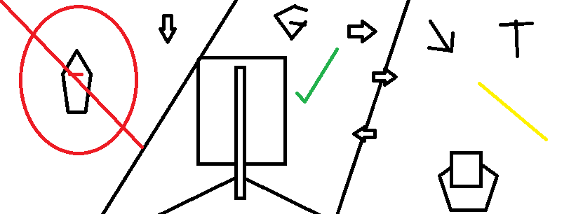

Concept Sketch of Camera Angles, ranging from top down, to third person overview. My opinion was that an “Ace Combat” style camera angle would be the best choice in game awareness in immersion, though everyone else felt that a more top down view would have been better suited.

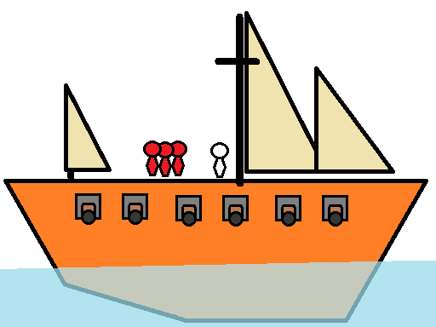

Concept Sketch of the player ship, as a paint doodle. With emphasis being on the player having sails, and ideally human / pawns of the ship’s crew on board.

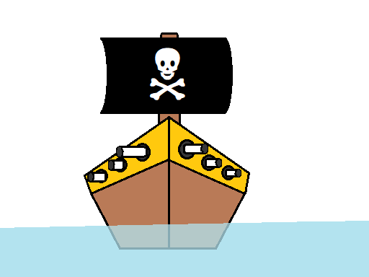

Concept sketch of a typical enemy ship, from a front perspective. Main idea for the initial enemies, is for them to be small boats with a pirate flag attached that are fast and agile in contrast to larger ships but less durable as a result. Later on, the player should encounter more durable and damaging, if less agile ships to have to sail against. Along with depending on assets available, a possible mythical creature to defend against.

# Storyboards

## Enemy

|  |
| --- |
| C:\Users\OneTw\AppData\Local\Microsoft\Windows\INetCache\Content.Word\Concept Art - Pirate Ship.png C:\Users\OneTw\AppData\Local\Microsoft\Windows\INetCache\Content.Word\Concept Art - Gameplay.png |
| The enemy that constantly chases the player, when in sight. Enemy ships should seek out the player, before strafing around the player’s position, and fire side cannon balls at the player. If the cannon balls hit the player hull, the player’s hull are damaged. If the cannon balls hit the player’s sails, the player’s sails are damaged. It should at most, take around 2-5 projectiles to destroy an enemy pirate ship, though this value could vary later, depending on gameplay balance. |

## Port

|  |
| --- |
| C:\Users\OneTw\AppData\Local\Microsoft\Windows\INetCache\Content.Word\PortStoryboardHack.png |
| For the short term, if/when the player lands on, or is near enough a port to ‘collide’ with it, they will gradually recover health for both their sails and hull. In the longer term, there should in addition, also be a visible prompt to launch a separate port menu from while nearby the port, which can be used to resupply the ship, acquire new crew, increase morale and buy upgrades, along with acquire quests and prompts to continue a story, gameplay direction wise. |

## Menu

|  |
| --- |
| C:\Users\OneTw\AppData\Local\Microsoft\Windows\INetCache\Content.Word\Menu.png |
| When the game loads, a main menu is loaded, displaying the options to play/load the game, view the instructions on how to play the game, tinker with the game’s resolution and graphical/volume options, and to end/quit the game in general. |

## End Game

|  |
| --- |
| C:\Users\OneTw\AppData\Local\Microsoft\Windows\INetCache\Content.Word\Sunk Hull Bad Doodle.png |
| If, during gameplay. The player loses all of their health in the hull. Then their ship will sink, and the game will either end. Or they’ll respawn back in the port. Later on, when a Graphical User Interface for menus, ports and shops are implemented properly. Can we think of adding an extra “quit/save/stop game” function within the game itself, through an in game menu load. |

## Instructions

|  |
| --- |
| C:\Users\OneTw\AppData\Local\Microsoft\Windows\INetCache\Content.Word\Halp Sketch.png |
| Within this menu, lies in general the instructions of how to play the game. Though the rough text so far only talks about how to control the ship. In future, the instructions screen should also talk about how to repair your ship, port wise. How to manage/view the crew, stats wise; and end game conditions in more clarity. Such as “until death or story/final boss is killed” sort of angle. |

## Crew/Taverna

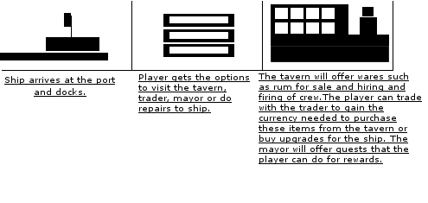

# Asset List

For comprehensive list of assets used please, see Appendix 5. Most of assets will come from Unity’s own asset store for the game. Some assets such as music and voice-overs will be, produced separately.

## UML

### Ship

### 



### Enemy AI





# Player Artificial Intelligence

Player AI is dependent on player input, controls wise. So far, player input adjusts the variables involving velocity of the player ship, which in future I would want to have linked in the nav mesh map. In addition, the player’s ability to move should be mainly dependant on the health of its sail, and possibly the health of its hull. For all ships, if their hull’s health reaches zero, it dies/is sunk. While as it’s sail’s gets damaged, the ship becomes far slower.

# Enemy AI

Current enemy AI is under one state; move towards the player, forward facing to the player as the ship navigates through the map to eventually ram the player, themselves. Ideally, I feel that the AI should ideally move a bit ‘like’ the player, in wandering around, and either circling around an enemy ship to attack, or sail straight through the ship to ram them down.

Ideally, if given time. I’d like for there to be at least three state’s; where friendly or unaware ships wander around random points, where an enemy ship is chasing the player, and where an enemy ship is circling/pointing their sides towards the player once they’ve reached a set distance, to fire their cannons at the player themselves.

If an enemy’s side is pointed at the player, then that enemy will fire/launch their attacks at the player, who then must dodge them to avoid taking damage. Dumb enemies will only attack the player’s current location, while ‘smarter’ enemies will try and aim a ‘notch’ before the player can steer out of the way.

# Navigation

## Ship Movement/Terrain

### The Ship Movement

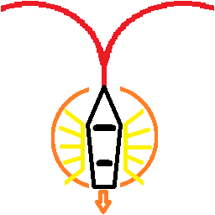The ship can only move in two ways; through rotation and momentum. With the ‘rotation’ being more akin to a steering speed, dependant on the momentum, and the momentum being influenced to go either full sail, slow rowing speed, anchored or slowly row in reverse. Even if anchored/not moving, the ship can still rotate (at a less efficient pace.) In addition, depending on the Sail’s Health/status, the ship’s top speed can be, vastly affected. Such a feature will however, be dependent on if multiple hitboxes have been included. If so, can ‘cripple/bar’ the ship from moving at any speeds depending on the sail to navigate.

### Terrain

In a basic scope, there exists two terrain within the level, land and sea. With the sea ships being able to move within the sea terrain, but unable to cross/move through the land terrain. The land terrain will ‘typically’ be under the sea floor, barring cases of islands, and shore under land terrain.

Outside of the general terrain, there should also exist additional hazards that affect the terrain, especially on the sea terrain. First being Reefs; that both slow down ship movement and damage the hull/health of a ship over time. Second being water currents, that can force push a ship in a certain direction or let the ship move/sail a bit faster, that can be both, useful or detrimental to the ship’s own movement. The water currents should ideally be, placed at key locations, as to act as a sort of ‘shortcut’, and to prevent the player from accidentally sailing out of the world map.

While the land in general is impassable, and there might even exist some land bound enemies such as towers that attack at the player. The land can also contain ‘port’s or harbours where the player can recover from enemy damage, and potentially even acquire upgrades/sell goods while in a ‘town’ menu.

In addition, the player can also collide with other ships, of which the higher mass ship cannot pass through. Such a collision will lead/result in health damage, especially for the weaker ship that suffers from a collision against a larger ship’s ram/front side.

## Weather/Wind

### The Weather

The weather can also have a bit of an impact on the game world, and the ships (both player and AI’s) ability to move through the game map/world. From the Wind, that can affect the sail speed of the ship (see “Ship Momentum”), to clouds that can impose a ‘fog of war’ condition on the player’s ability to see far distances, to even storms that can make it even harder to see through rain effects, and the occasional thunder storm.

## Ship Momentum (Sails > Wind)

The ship’s minimum speed would be determined by a mix of the ship’s mass, and the amount of crew to act as ‘rowers’, whilst the Ship’s maximum speed being determined by the amount, and the strength/quality of the sails themselves, on top of if the ship is sailing to the current direction of the wind, and the wind’s strength.

Outside of that, a ship’s momentum should be set anywhere from ‘row crawling small’ for reversing and forward momentum, to (1/4, 1/3, 1/2, Full) Sail Speed, with the faster forward speeds being dependant on the sails condition. If Sail badly damaged, the player’s top speed will be, affected, but be no slower than ‘rowing’ speed as a minimum, when sails are destroyed. This can affect the ‘max’ speed allowed, being stuck at ‘half speed’ for mildly damaged sails, all the way to no sails enabled due to a destroyed mast.

## Miscellaneous

### (Map Compass)

There should also be a Compass that shows the ship’s (or camera’s) current rotation, along with if implementable; a map feature that ‘shows’ the revealed locations of the world amp. However, outside of maybe the compass; those features may not be able to be implemented (reasonably), depending on time constraints and lack of experience requiring the use of tutorials.

## Combat

### Attacking (Game Screen example)

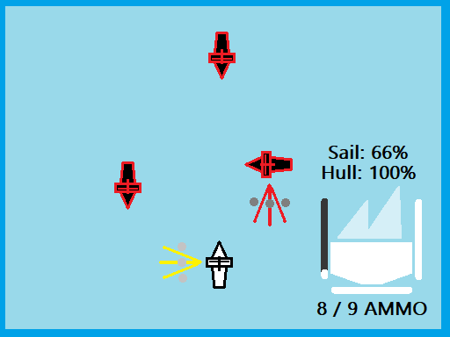

Combat is, mainly done through firing of cannons on the ships side and aiming the launched projectiles to hit enemy ships as to cause damage to their hull, sails and potentially even the crew themselves. Once fired, the side of the ship that fired cannons will take some time to reload before they can fire on that side again. This reload time can be shorter depending on the skill level of the crew on board.

On top of being able to fire projectiles on either side of the ship, some ships also have a ‘special ability’, that can either be reinforced hull, or ability to launch a special type of projection in a set direction (be it at the front, back or both sides.) However, special ability projectiles have a limited amount of uses (under ammo) and take a longer time to reload compared to standard attacks. Again, the reload time can be shorter depending on the skill level of the crew on board.

In addition, a fast and heavy ship can also try and ‘ram’ the player, through use of their front side of the ship. If the ship is fast/heavy enough, compared to the other ship, they can cause far more damage to the weaker ship, though at the expense of suffering from ‘light’ damage.

Lastly, though normal shots should ideally, only be fired from the sides. There should also exist the potential to upgrade the ship’s mains into becoming something more… aggressive, from being able to fire grapeshot and chain-shot, which can cause even more damage to the enemy ship’s sails or crew themselves.

## Health

Ideally, the Ship will be under two sort of ‘health’ variables; Sail and Hull. With the Hull being the ship’s overall “Health”, where if it is at zero, the ship will die/sink. While the Sail determines the ‘health’ of the ship’s speed, and if it is at zero, the ship’s movement will be severely crippled, leaving them a sitting duck to a more agile and aggressive enemy. For larger ships, there could even exist the possibility for separate hit boxes for different sails. If unviable, the health can be, simplified into only considering the ship’s overall condition.

If given the ability to separate damage, then I’d also consider the ratio of damage ‘spill over’, so that if a hull is damaged, sails get some damage and vice versa. The ship’s condition can ideally only be fixed/maintained while resting at a port, though this might come at the expense of the player’s resources. Ports can also be, used to resupply the player’s special ammo, along with potentially enable tweaking of the ship layout.

## HUD (User Interface)

### The HUD

The Hud should display the following things for the player’s status.

* The Ships condition, in certain sections. (Mainly, on the Ship’s sails, and overall condition of the Hull.)
* The loading status of each cannon (if it’s ready/reloading, and the amount of ammo/overall condition to the special attack bar.)

In addition, if viable; the player HUD should also display a compass, and a rough world map of the player’s current position, line of view, and display any icons of ‘visible’ enemies within the HUD.

# Audio

The Audio for the game will consist of WAV and MP3 files for voice-overs, background music, cannon fire, wind etc. These are, edited through Audacity. Free software used for making audio files in different formats. Files are, added into Unity via asset management. The style of the audio files are, loosely be based, on music from movies such as Pirates of the Caribbean and other Pirate movies from early cinema. At, this present time no audio assets have been made or used within the prototype of the game and therefore not added to list of Assets.

# Technical Design

## Platform

The initial platform we are planning to release the game on PCs that are running Windows 7 – 10 and plans to release for additional platforms such as Linux and Mac PCs at a later date.

At, the moment, no plans are set to release versions compatible with Web, Mobile or Console devices through this can be set to change if the need for the game to be released for these devices is required within the future.

## Hardware

The hardware needed to work on the project as well as play the finished product are:

* PC or Laptop with the capability of running the latest version of the Unity program with either Windows 7 or 10 operating system and the following specs:
* 4gb RAM
* Core I3 or AMD A6 CPU
* Intel HD Graphics
* Headphones or speakers
* Keyboard or wireless mouse
* Internet connection with min 2mb broadband

## Software

All software that will used to work on the project is:

* Unity 2018.2f8
* Visual Studio or MonoDevelop
* Audacity
* Maya, Blender or other 3D model software

Software required to play the game will be only the installer we provide.

## File Formats

All audio assets will be in either:

* WAV
* MP3

Any assets required for the project will be:

* 2D saved as a PNG
* 3D saved as a FBX

All documentation will be, written and saved in either Microsoft Office, or programs that support and write files into Office formats such as Google Documents or Apache Open Office.

# Development Environment

Our primary development environment will be the Unity Engine, with code being, written in and external editor of the team member’s choice. Visual Studio and MonoDevelop have full integration support with Unity and provide a range of features useful for quickly writing and refining code, though other editors are available to be, used.

Unity was, chosen over other available game engines due to team familiarity with the software and the C# programming language.

Git will be, used for version control on the project, with GitHub being, used for hosting our repository.

Google Drive will be, used to share larger files where they cannot be, easily shared via other communication software.

Assets will be, developed in a number of other pieces of software, and saved following the File Format, advice above.

## Mechanics and Gameplay

### Over world

On the over world the player will be able to move their ship, experience combat encounters and access ports.

### Movement

The player ship will be, controlled via the keyboard. Pressing forward will unfurl the sails and increase speed. Pressing backwards will have the opposite effect. Pressing left and right will turn the ship.

### Accessing Ports

If the player moves their ship close enough to the port, a small icon, popup or other visual or audio cue will notify them that they are able to dock. Pressing the “Interact” key will pause the game world and open the interface for the port. Exiting this interface will un-pause the game and allow the player to move again.

### Combat

A player’s ship will have an array of cannons with which to shoot enemy ships. Pressing the “Fire” key will fire the cannons. A “reloading” timer will initiate preventing rapid firing. Once the timer has reached zero, a visual or audio cue will alert the player that they can fire again.

Cannon balls will fire from the sides of the ship. They will follow an arced trajectory. If they make contact with an enemy ship, they will inflict damage. Once the enemy ship has sustained enough damage, it will sink.

### Ports

When in the Port interface, the player will have access to the Inn, the Shipyard, trading and quests.

#### Trading

The player will be able to open a trading interface where they can transfer goods from their hold to the town or vice versa. Trade prices will be, displayed next to each good. The player will not be able to purchase anything they do not have the money for, or the space available in their ship to hold.

#### Quests

The player will be able to open a questing interface where jobs can be, listed with the reward that will be, provided on completion. Quests can involve delivery of goods to another town, acquisition of goods from another town, a combat encounter with a specific ship, or a kill count. Quests can be, completed by returning to this screen and handing them in, at which point the reward will be, provided to the player.

#### Inn

The Inn is the main crew management interface. See the Living Crew section below for details on crew management.

#### Shipyard

The shipyard will provide an interface for upgrading or otherwise managing the player’s ship. The player will be able to purchase upgrades to different parts of their ship, resulting in enhanced performance in the over world and a possible visual change. The player will be able to purchase improvements to the following:

* Sails – Increased acceleration and/or top speed.
* Hull – Increased turning speed and durability.
* Cannons – Increased number of cannons, increased damage.

#### Living Crew

The crew will have stats showing their health, morale, hunger and thirst so the player can keep track of how happy their crew is and know when it's time to take care of their needs before the crew comes too unhappy and has a mutiny which might involve the ship losing their captain, etc.

# Prototype (Demo)

As shown within the presentation video; the current prototype as it stands, has at least functional combat mechanics, though the AI and movement scripts still need some fine tuning. In addition, the prototype also has a working menu, implemented support for gradual health recovery at ports, along with more detailed terrain and still in progress shop menu and crew statistics.

# Critical Appraisals

All have been done and uploaded separately by each individual member within the team.

\***See individual Appraisals, for Critical Analysis**

Conclusion

As a disclaimer; odds are this documentation is not up to the highest standard, or covers everything that should be included within a Game/Technical Design Document that we are able to work on in the second Trimester. This is mainly due to by deadline; not only did B00307865 not turned up on the final day using health reasons as his reason, but also didn’t even bother to; upload any documentation that he has done that he was explicitly told to have done by now, while he had the chance online. As such, we took over when it comes to updating and ensuing this document on the content he was tasked to cover by hand-in time. Though thankfully, we had an earlier version to build on and check over things, the fact remains that B00307865’s conduct, risked the stability of this document being handed in on time, and in a finished state.

# Appendices

**\*For video, see the separate upload.**

## Appendix 1

### Discord Chat

moffs1**23/09/2018**

@loth what you want Andrew to do for Games development project before Wednesday

loth**23/09/2018**

Um...

Flesh out info about the features in the navigation / combat.

How they'll work in a general sense and how anything interacts with anything else.

Doesn't need to be super detailed, not after that, but the general "The player will have multiple weapon options they can switch between, here are some examples: Cannonballs, Explosive charges, Grapeshot."

Still all just game design notes, not technical design though, so don't worry about implementation just yet, we'll do a risk analysis when we get together on wednesday and point out issues then, as it'll give us a good couple of "we planned X but needed to scale back to Y" items for the doc

Kirstin \*Alillith - Valour\***23/09/2018**

most likely will be researching castle designs. As said, only have a few castles in range for design ideas and Culzean is more moderinish.. I would go more toward what Greenan or Dunure use to look like.

but right now, I am more worried about working coding than actual design. if the code works than more time to worry on the overall design.

24 September 2018

moffs1**24/09/2018**

@Kirstin \*Alillith - Valour\* When you arrive today you may need to use the keysafe to get in as Andrew has dental appointment the no 1701 we should only be 20 mins

ArcaneHermit**24/09/2018**

One thing, well few things we've had stumbled upon while working on the Game Engine II project

One, or first. Since I've a high feeling I could easily mix the two projects together, I've (after some hassle), setted up another Trello board, and renamed the other project to be more 'findable'/seperate from the other

<https://trello.com/b/uPsrvTBp/group-roles-game-engine-ii>

[Trello](https://trello.com/b/uPsrvTBp/group-roles-game-engine-ii)

Organize anything, together. Trello is a collaboration tool that organizes your projects into boards. In one glance, know what's being worked on, who's working on what, and where something is in a process.

<https://trello.com/b/sG72VwYw/group-roles-development-project>

[Trello](https://trello.com/b/sG72VwYw/group-roles-development-project)

Organize anything, together. Trello is a collaboration tool that organizes your projects into boards. In one glance, know what's being worked on, who's working on what, and where something is in a process.

So, bad english aside. Those are for easy to refer to later, general task management for all of us, task wise

-

Second, while we were working on our little roles. @Kirstin \*Alillith - Valour\* well. Is dealing with a few technical difficulties, no thanks to a not functioning tutorial when I double checked with it's "Master code", on Unity proper.

Though I've a feeling that she'd eventually, if given enough time 'might' be able to fix the inventory, given enough time... Maybe.

Kirstin \*Alillith - Valour\***24/09/2018**

It's going to take a bit of time to get the database/invo working. found a tutorial that is working but we need to discuss colour schemes, etc. it won't be a invo that the player can click to open and close at the moment.

26 September 2018

moffs1**26/09/2018**

we are in E113B for the lab and lecture this morning as no lecture

ArcaneHermit**26/09/2018**

First Draft on my assigned task, given a rough polish. Hope it's acceptable for now.

[Game\_Development\_\_Sails\_of\_Santiago\_Project\_Draft\_Mk1.1\_AIL.docx](https://cdn.discordapp.com/attachments/489380481901789197/494445614503952384/Game_Development__Sails_of_Santiago_Project_Draft_Mk1.1_AIL.docx)

63.13 KB

loth**26/09/2018**

I'm on my way in, slept through my alarms

28 September 2018

loth**28/09/2018**

In paisley, there shortly

loth**03/10/2018**

Should be there for 10,

ArcaneHermit**03/10/2018**

Finished a rough draft, for the UML Flow for this project. A Bit rough, and no doubt may require a bit more tweaking, but it's done.

[AIL\_-\_UML\_-\_Navigation\_and\_Combat\_-\_Flowchart.vsdx](https://cdn.discordapp.com/attachments/489380481901789197/496968129222672414/AIL_-_UML_-_Navigation_and_Combat_-_Flowchart.vsdx)

102.14 KB

An alternate style I did while doing the flow chart, putting those functions into neat boxes, just in case it flows better, say.

[AIL\_-\_UML\_-\_alt\_Navigation\_and\_Combat\_-\_Flowchart\_Draft\_A.vsdx](https://cdn.discordapp.com/attachments/489380481901789197/496968626843156490/AIL_-_UML_-_alt_Navigation_and_Combat_-_Flowchart_Draft_A.vsdx)

110.59 KB

5 October 2018

ArcaneHermit**05/10/2018**

Added some references that may be related to the subject. But couldn't find anywhere to do a Harford Referencing system. Also supplied English terms for slang, just to be on the same side; something explanation of jargon wise?

[AIL\_-\_VR\_Paperwork.docx](https://cdn.discordapp.com/attachments/489380481901789197/497700225377632266/AIL_-_VR_Paperwork.docx)

241.63 KB

moffs1**05/10/2018**

It's Harvard is numpty

ArcaneHermit**05/10/2018**

.... Just for that, just to be vigilant; I'll give this another document draft/read through now. JUST to make sure I get it hammered down, without any further issues. Especially when Harvard referencing is involved.

ArcaneHermit**05/10/2018**

And so far, making changes to that uploaded document, to make sure it's fully Harvard reference friendly. Especially when links are involved

ArcaneHermit**05/10/2018**

Leavin' this here, for reference. But me and @Kirstin \*Alillith - Valour\* didn't saw @loth today, class wise. I dunno if it's a one off, or tiredness. But if at all possible, I'd want to at least discuss what else needs to be done through voice channel, once I've done fixing my paperwork a notch further, referencing hell wise

Kirstin \*Alillith - Valour\***05/10/2018**

Not sure if will be up for voice channel. Not feeling well and most likely will fall sleep during it. :/

Just going to code the equipment stuff through, can always take it off the final game. Using the UI the tutorial has at the moment.

8 October 2018

loth**08/10/2018**

Hey, my gran is ill in hospital, it's terminal cancer and the family are all on standby. Are either of you able to sit down with me tomorrow to make a plan of attack for the projects? Help me build my task list so I can focus more on the 'doing' rather than 'figuring out what needs doing'.

ArcaneHermit**08/10/2018**

I am always available. And... ouch, no wonder why you weren't there earlier.

loth**08/10/2018**

I try not to mix too much personal into work, and my anxiety can make it difficult to get back in touch when I've missed something... :s Sorry for dropping off.

Looking to bury myself in my work for a bit though

9 October 2018

Kirstin \*Alillith - Valour\***09/10/2018**

Might be a bit late. Trains are kind of messed up and my other laptop is down at the moment. The display isn't working so I got the dino with me today.

Kirstin \*Alillith - Valour\***09/10/2018**

Any chance you might be in to work on the website for the missile game, @loth

loth**09/10/2018**

I'll boot up my computer and dig in here. You're happy with how we discussed it? "Missile command with physics forces"?

Kirstin \*Alillith - Valour\***09/10/2018**

Yep. Just need to work on the website part right now.

10 October 2018

loth**10/10/2018**

I'm on my way in, hopefully there for ~0930

ArcaneHermit**10/10/2018**

In advance, a quick doodle over simple logic, which ideally would lead to easier to manage sails with just scale, instead of scale and move the sails up/down

[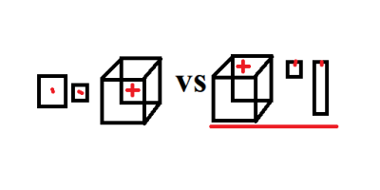](https://cdn.discordapp.com/attachments/489380481901789197/499528731203862528/Scale_Sail_Box_Doodle.png)

Problem with that being, depending on how far unity is in editing centre/pivot points, may have to do it in Blender/Maya, which is a hassle. Now, to work on cannons! Basic movement on my current prefab is working AOK

11 October 2018

Kirstin \*Alillith - Valour\***11/10/2018**

Well, Over the last day, the laptop has been showing enough display for me to grab a few files off so I am not really sure what the issue is so probs be up next week to work on things for the projects.

12 October 2018

loth**12/10/2018**

Been on the bus for 20 mins and it's barely moved. Might be a jam or accident ahead in the Clyde tunnel or expressway. I am on my way, just, slowly...

ArcaneHermit**12/10/2018**

thanks for the warning

Kirstin \*Alillith - Valour\***12/10/2018**

On train myself. The weather is pretty bad in Ayr so wasn't rushing for the usual train

loth**12/10/2018**

I'm on the train, get to paisley for about 0925/30. So see you soon.

16 October 2018

loth**16/10/2018**

What classes are on tomorrow? Just the afternoon one?

Kirstin \*Alillith - Valour\***16/10/2018**

As for as I know it's your choice to attend. I know I plan to be in to work on the blog.

ArcaneHermit**16/10/2018**

Oh, thanks for the info there's people on tomorrow?

I thought it's consolidation week and such. That said, just in case it becomes an issue, I recall there's a paperwork deadline on the 22nd

But that's nothing, compared to blog. Which I'm on the last part, review wise... And making sure to check my second last blog post on top

Kirstin \*Alillith - Valour\***16/10/2018**

Gavin said there was two more due to give presentations. I personally rather spend the time on the blog.

The networking one I am finding trouble on how to start it, have ideas, just putting them into words.

loth**16/10/2018**

I was sure it was only the Afternoon professionalism class that was on but wanted to double check

I'll be coming in, so can meet up and we can be the only three in the audience haha

Kirstin \*Alillith - Valour\***16/10/2018**

Lol. Well, it helps to bounce ideas around.

Find it easier on a topic if someone there to discuss it with. Can't talk networking with my mum.

ArcaneHermit**16/10/2018**

In my own words, list what networking is, and maybe go from there.

The assessment had some tips on what you can focus on, so consider using that as a base

Kirstin \*Alillith - Valour\***16/10/2018**

That is what I am doing like listing a little about each ip , etc. Just deciding if I want to say the that stiffles creativity or not. Looking at the new games coming out, etc, can't say ip is really stiffling anything.

Just the tips for the networking one don't give me ideas on how to start the blog into the ideas but I might research a little tomorrow. I am almost done blog 2. Just proofreading and trying to add those four pillars in.

Kirstin \*Alillith - Valour\***16/10/2018**

Also do we need to have a conclusion?

loth**16/10/2018**

hm, it's usually good to sum up your thoughts at the end of any 'think-peice'

Depends how you've written it, but a short "This is what I think, what do you think? Let me know below, like, subscribe and share, buy my t-shirts, mouse mats, mugs..."

Kirstin \*Alillith - Valour\***16/10/2018**

Lol. Was thinking of concluding the freelancing one with at this moment, I don't think freelancing is for me after weighing all the pros vs cons.

loth**16/10/2018**

Yeah, that is a good way to go on that one.

You've looked at the benefits, and think it's not for you now that you have.

Kirstin \*Alillith - Valour\***16/10/2018**

I think to freelance, you need to have fiances to back it up.

That is the reason I feel at the moment I wouldn't go down that path.

17 October 2018

ArcaneHermit**17/10/2018**

Glance wise, Freelancing depends on Networking as well as constant Job seeking. At least, that's what I recall in hindsight.

Savings ain't required per see, but desired given the patchy profession in job security

Kirstin \*Alillith - Valour\***17/10/2018**

Yea. Covered that already. Your always job hunting, lol

ArcaneHermit**17/10/2018**

At the end, it's your piece. In my end, I tried to briefly list pros and cons

Kirstin \*Alillith - Valour\***17/10/2018**

And if you want to be comfortable, better to have some savings before going into freelancing and we all have different ideas.

ArcaneHermit**17/10/2018**

That said. I did said emphasis on ideal, given how you could end with periods without work. Or have to deal with other expenses on your end

Kirstin \*Alillith - Valour\***17/10/2018**

Same. You have no guarantee of steady work.

ArcaneHermit**17/10/2018**

... also, has anyone attended Uni today? Got insisted on checking, as I've done a rough draft on the final week part

Kirstin \*Alillith - Valour\***17/10/2018**

Yea. Even signed in, lol.

ArcaneHermit**17/10/2018**

PS: To a base degree; got firing to work. Should be if on it, simple to build from there...

[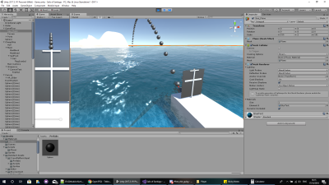](https://cdn.discordapp.com/attachments/489380481901789197/502137700225384448/unknown.png)

loth**17/10/2018**

Can you have a look at getting the project files added into the team collaboration thing in unity?

I set you both as managers so you should have rights

ArcaneHermit**17/10/2018**

If I can, then yeah. Past that, been meaning to upload it onto Github as well

ArcaneHermit**17/10/2018**

Still can't access it though, glance wise. As I require a "seat" apparently

I get this thing when I Try loading your samples.

[https://media.discordapp.net/attachments/489380481901789197/502151625272459294/unknown.png](https://cdn.discordapp.com/attachments/489380481901789197/502151625272459294/unknown.png)

ArcaneHermit**17/10/2018**

in advance, mind leaving emails here, so I could if hassle wise happens, add you on my group instead? Because as is; I'm having some issues trying to move/shift the project to your organisation

ArcaneHermit**17/10/2018**

decided to try and loading it on github, since it's less hassle

I'll provide a link once done, so hopefully it'd be easy tinkering from there

ArcaneHermit**17/10/2018**

here

<https://github.com/AndrewLetailleur/SailsOfSantiago_UnityProject>

GitHub

[AndrewLetailleur/SailsOfSantiago\_UnityProject](https://github.com/AndrewLetailleur/SailsOfSantiago_UnityProject)

a group project for a University project. Involving me, Kirstin and Gary - AndrewLetailleur/SailsOfSantiago\_UnityProject

[](https://github.com/AndrewLetailleur/SailsOfSantiago_UnityProject)

18 October 2018

ArcaneHermit**18/10/2018**

Hey, just throwing a check, to see if any/all of us are going to meet up tomorrow, Uni wise?

loth**18/10/2018**

I can do up til ~1500, then need to leave

ArcaneHermit**18/10/2018**

cool, just need to check on the status of @Kirstin \*Alillith - Valour\* lastly, because if everyone can be there, then I'd be bound to at least meet up. Especially since I no longer have to worry on the blog any more. Fully uploaded

moffs1**18/10/2018**

@loth @Kirstin \*Alillith - Valour\* was wondering I'm just back from hols do u need to be at uni tomorrow or not. Just in case Andrew is needed or not

loth**18/10/2018**

No classes, consolidation week. I've still to finish my last blog article but only the one.

Happy to come in though.

moffs1**18/10/2018**

If consolidation week best to use it for advantage. So me and Andrew won't be there tomorrow. Anything u want him to do post it here as no point to travel up if nobody turns up. I will get him to work on projects tomorrow instead

loth**18/10/2018**

Kk, ;)

Kirstin \*Alillith - Valour\***18/10/2018**

I will be in tomorrow to finish up the last bits of the blog.

19 October 2018

ArcaneHermit**19/10/2018**

Currently going to be giving the group project a bit of a crack. But before I think of doing so, I may as well attempt to re parse/say an issue I've had with @loth 's request, Gary wise

Well, on the Unity Collab assets. I was unable to 'sync' the project within your group, @loth . On top of that, I was unable to hypothetically add you on my group so easily, by lack of email. On top of the hassle on trying to assign/get seats, before I can even share/access the project's. Because Unity functions under a "Seat" mentality when it comes to access. In a way, that's more secure than Github. But well... Limited seats. EDIT: Which led to me having to short term, set up a Github project as a 'fallback' in sharing/syncing the project. Hassle wise.(edited)

- So in a nutshell; unless I say; have both of your email accounts so I can "try" and add you two's to my group, @Kirstin \*Alillith - Valour\* & @loth . Or we get seat privilages. I don't see Unity Seats/Cloud collab working.

ArcaneHermit**19/10/2018**

so far, hack wise on the sailing project. Got sailing sails to go superb. Just tinkering to make sure the projectiles go alright as well. I'd tinker with sails a notch more, but then I'd eat too much time on it

ArcaneHermit**19/10/2018**

okay, I've finally had the time to do one last, read through on my current VR Paperwork and such, est. I know I've uploaded an initial draft. But forgot to include Harvard referencing on it. So this version includes that, plus a few more links of relevance in case it becomes a hassle to find them later

Though in truth, I've only had to add one extra link, and triple checked the referencing in boxes. The reference boxes may, or may not need to be ammended/tweaked however, to fit within a master document. Due in by the 22nd I recall.

[AIL\_-\_VR\_Paperwork\_Mk2.docx](https://cdn.discordapp.com/attachments/489380481901789197/502861961361620992/AIL_-_VR_Paperwork_Mk2.docx)

234.69 KB

Kirstin \*Alillith - Valour\***19/10/2018**

The paperwork for Tues is now due with the rest. Mario sent a message via Moodle.

20 October 2018

ArcaneHermit**20/10/2018**

sent an updated paperwork on my end, just need to wait for Gary to ensue everything's ordered and such.

ArcaneHermit**20/10/2018**

Brief update, because whoa! Sails

PS: Gonna see after tinkering with some things, adding a basic enemy

[[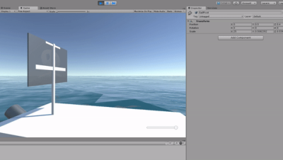](https://cdn.discordapp.com/attachments/489380481901789197/503196903945797632/SailsWorkTinker.gif)](https://cdn.discordapp.com/attachments/489380481901789197/503196903945797632/SailsWorkTinker.gif" \t "_blank)

loth**20/10/2018**

lothariopendragon@gmail.com, sorry

Yeah, it is a bit weird how they sort stuff, hopefully we can get it working, else, GitHub is good for me

Will be available through the day tomorrow, and through the day on Monday to chat on discord if anyone wants to try sorting the Team Collab stuff?

21 October 2018

moffs1**21/10/2018**

@loth @Kirstin \*Alillith - Valour\* @ArcaneHermit if you require Andrew to do any more paperwork message here as he will be monitoring discord all day

@Kirstin \*Alillith - Valour\* are you coming to visit on monday

ArcaneHermit**21/10/2018**

To be blunt. I've done what I (Think) is required on my end, and am currently awaiting further orders, or tasks to be done for the Game Engine II, paperwork wise. So if you're in need of any additional work done, or last minute help with areas you're honestly struggling in work. PLEASE, let me know @loth

EDIT: Past that (verbose) comment; by luck, I've managed to assign by hassle, Unity Teams (Basic) to all of us, under my name. So if you couldn't access my stuff from uh, Unity Cloud before. HOPEFULLY, you should so now, if under my name @Kirstin \*Alillith - Valour\* & @loth(edited)

\*Evidence

[](https://cdn.discordapp.com/attachments/489380481901789197/503478171883143208/unknown.png)

Kirstin \*Alillith - Valour\***21/10/2018**

Still waiting for the medion to be repaired, so might not be worth me lugging the dell up when it's slow for gaming needs. More depending on the uni systems till the other one is sorted.

ArcaneHermit**21/10/2018**

To be brief, seeing what I can do in programming on the other project for now. But while I'm at it, enabled Unity Collab on it as well, under my name/est

Also, beyond a doubt enabled access to seats. Both on my and Gary's end of accoutns. Good thing for manager status, yo.

loth**21/10/2018**

I'm launching it now to give it a check on my end! Fingers crossed

loth**21/10/2018**

I have access to the dashboard etc, currently looking for how st to download the project.

loth**21/10/2018**

I have it downloading btw, my internet is just *that slooowwww*

loth**21/10/2018**

success

[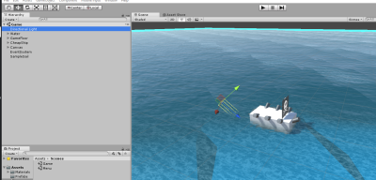](https://cdn.discordapp.com/attachments/489380481901789197/503589630806065162/Capture.PNG)

ArcaneHermit**21/10/2018**

FORGOTTEN UML Flowchart thingie for Enemy AI at least. Gonna check what else to do

[ER\_Flowchart\_ENEMY\_AI.vsdx](https://cdn.discordapp.com/attachments/489380481901789197/503643228936077333/ER_Flowchart_ENEMY_AI.vsdx)

85.85 KB

22 October 2018

ArcaneHermit**22/10/2018**

Since I forgot to do ze flowcharts, may as well lend a hand and do the flowcharts for stuff/est.

[Flowchart\_Menu\_AIL.vsdx](https://cdn.discordapp.com/attachments/489380481901789197/503922394650640404/Flowchart_Menu_AIL.vsdx)

49.86 KB

So on that end, I need to speak with everyone to get a gauge on how everyone's own part of the game is going along, and see if I can UML it for your specifications and such.

function wise

23 October 2018

Kirstin \*Alillith - Valour\***23/10/2018**

Be working on game stuff today. Light on have to upgrade unity on the dino or see if the tablet will handle the new version.

Still got to fix the screen of the dino, got a line running down it. So far the tablet hasn't given me grief.

24 October 2018

Kirstin \*Alillith - Valour\***24/10/2018**

Be a little late, train not the fastest, lol

Kirstin \*Alillith - Valour\***24/10/2018**

@loth think the project can be accessed under the projects option, I need to update my unity on the dino tonight.

ArcaneHermit**24/10/2018**

Until then, in case I forgot to mention. Got in functionality, the GUI To work more or less, as intended. With a firing/ammo limitation on the special ammo

May need some tinkering to make sure the cannons fire in the right well; way. But for now, I feel it should suffice. Just working on getting multiple colliders between hull and sail to work next, along with health deduction experiments on tow

moffs1**24/10/2018**

@Kirstin \*Alillith - Valour\* yr singed on register we are about to go u want me to keep yr card till friday

25 October 2018

loth**07/11/2018**

Will be there for about 12:30

Kirstin \*Alillith - Valour\***07/11/2018**

We've left but if anything you want done, let us know through here.

8 November 2018

ArcaneHermit**08/11/2018**

In advance, just did a light glance over on AI and such on standard assets, and included support and such for NavMesh Components for the Game Engine II project

All in order for future support/programming on actual content

9 November 2018

moffs1**09/11/2018**

@Kirstin \*Alillith - Valour\* @ArcaneHermit here is Gary's email lothariopendragon@gmail.com to contact gary

moffs1**09/11/2018**

@Kirstin \*Alillith - Valour\* @loth Andrew was talking on train and reckons for quickness/easiness that having zombies & soldier's for both game engine2 levels due to time constraints. Also @Kirstin \*Alillith - Valour\* he said if u need help with database for game just to ask him.

loth**09/11/2018**

Okay, soldiers/zombies works for me

@Kirstin \*Alillith - Valour\* I caved. I am accepting zombies.

Kirstin \*Alillith - Valour\***09/11/2018**

Lol.

The invo is working so far. Probs be heading to nab lunch and a train home. Think the weather is gonna turn nasty.

loth**09/11/2018**

There's that bad weather...

12 November 2018

ArcaneHermit**12/11/2018**

For everyone's info; I've hack wise, managed to get a... sort of better detail to ships. However, sail feature is a bit... massively buggy ATM. So going to be spending some time fixing that, and other movement hassles.

Kirstin \*Alillith - Valour\***12/11/2018**

Gonna see if I can get something of a stat menu working.

Kirstin \*Alillith - Valour\***12/11/2018**

[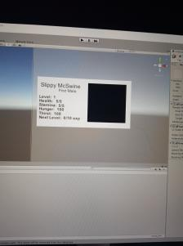](https://cdn.discordapp.com/attachments/489380481901789197/511663369464578059/20181112_220712.jpg)

Hoping I can tweak the invo code for the prototype to work for this but pretty much we need to decide what the stats are going to be.

ArcaneHermit**12/11/2018**

Kirstin \*Alillith - Valour\***12/11/2018**

Right now it's going to be accessible like the invo, I'll figure out how to get it work via button if time to do so.

Kirstin \*Alillith - Valour\***12/11/2018**

@loth you planning to be in tomorrow so we can get things done with the documentation, etc?

13 November 2018

ArcaneHermit**13/11/2018**

Just a bit of debugging on the sail shifting code. And currently it's a hassle, trying to update all that big lists.

[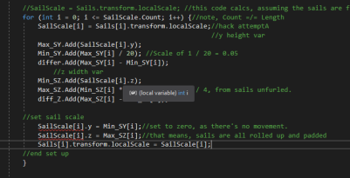](https://cdn.discordapp.com/attachments/489380481901789197/511814612761706506/unknown.png)

in advance, the precise bug in question I (currently) have, is this;

[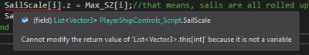](https://cdn.discordapp.com/attachments/489380481901789197/511815284139622421/unknown.png)

loth**13/11/2018**

Aiming to be in for 1030/1100

Kirstin \*Alillith - Valour\***13/11/2018**

Be in around 1130.

\*I

loth**13/11/2018**

Here's the main doc so far

[SoS\_-\_Game\_and\_Technical\_Design.docx](https://cdn.discordapp.com/attachments/489380481901789197/511888856656773120/SoS_-_Game_and_Technical_Design.docx)

332.35 KB

loth**13/11/2018**

Initial glance from Gavin and content wise he's approving. Will source images etc and get sketches made and put in. Will move onto technical design sections as well.

ArcaneHermit**13/11/2018**

okay, been reading a bit, and it looks like I'd have to update the Unity version I was using. If what you wrote on the document is true

Because until now, it was under 2017 instead, project wise EDIT: For the Sails of Santiago one(edited)

14 November 2018

loth**14/11/2018**

Added more to it.

[SoS\_-\_Game\_and\_Technical\_Design.docx](https://cdn.discordapp.com/attachments/489380481901789197/512234747171438592/SoS_-_Game_and_Technical_Design.docx)

335.19 KB

ArcaneHermit**14/11/2018**

So I recall @Kirstin \*Alillith - Valour\* still having hassle when it comes towards emails. For sanity's sake., I'll use in reference the

Body upgrades, but eh.

//Lazy Inventory Management

//bias here, is to get colliders.

//Then grab an incremental player variable, to update/show on a GUI

//CollisionEnter (trig or col)

//if (collide.tag = "Medicine")

//player.Medicine++; //so you get your loot

//destroy.("Medicine");// so you enjoy witches burning houses down?

16 November 2018

Kirstin \*Alillith - Valour\***16/11/2018**

I should have a working invo now. And emails?

loth**16/11/2018**

Be there in a min

Kirstin \*Alillith - Valour\***16/11/2018**

Just getting a new things and will be there in about 5 mins

\*few. Damn I hate this autocorrect.

17 November 2018

ArcaneHermit**17/11/2018**

I know this might be a possible concern for some. But if lighting is a hassle, keep a mind on this;

<https://answers.unity.com/questions/1009935/how-to-avoid-annoying-baking-in-unity-5.html>

[How to avoid annoying baking in unity 5 - Unity Answers](https://answers.unity.com/questions/1009935/how-to-avoid-annoying-baking-in-unity-5.html)

Unity is the ultimate game development platform. Use Unity to build high-quality 3D and 2D games, deploy them across mobile, desktop, VR/AR, consoles or the Web, and connect with loyal and enthusiastic players and customers.

[https://images-ext-1.discordapp.net/external/su436TggGlTxfWmrhgGS2l-aoV3JNgqAV1qM1D3L2rg/https/unity3d.com/files/images/ogimg.jpg?width=80&height=42](https://answers.unity.com/questions/1009935/how-to-avoid-annoying-baking-in-unity-5.html)

It might be dated, and need to likely tick out "Auto generate" in debug. But that said, it'd save a lot of hassle on memory, before you go full debuggy

18 November 2018

loth**18/11/2018**

I'm making a set of scenes for initial load in and initialisation, switching between scenes etc. A Preload scene where I initialise the Game Manager class, the Audio Manager will do the same here as well, and if there are any other Singleton style classes we'll start them here.

I've uploaded my changes from Friday so far and will keep working on it.

My desktop doesn't have the right version of Unity, so that's where my issues were coming from. Continuing on my laptop for now.

This set of scenes/classes will be useful in both projects, needing at most a few minor changs here and there.

ArcaneHermit**18/11/2018**

In advance, am later on going to finish working on the lighting effects, and start work on the enemy placement. At the very least, I hope if you're ever working on lighting, or having hassle with constant baking eating up RAM. The link above would be of critical help

Especially when in a nutshell, some lighting effects can go a long way in making a realistic scene, I feel.

loth**18/11/2018**

Yeah, I always forget to turn off the auto bake stuff until I notice I'm waiting minutes after attempting to play

Kirstin \*Alillith - Valour\***18/11/2018**

Not really fussing with lighting on my end. Figure that will be done when everything is brought together.

ArcaneHermit**18/11/2018**

It's auto generate that's the major thing. I'd still say it's important, especially when you know beyond a doubt all the lights are done. But eh, I can only hope for the best from here.

ArcaneHermit**18/11/2018**

also, forgot to note. But thanks for updating the project for me @loth

ArcaneHermit**18/11/2018**

As far as I recall, done with the lighting for reals. So from now on, I'd only worry about the enemies.

Did a few quick tricks/fixes, but maybe it'd serve as some hypothetical inspiration, if at a lazy glance, I trigger an "exit gate" condition for some hinted sun, per say?

20 November 2018

Kirstin \*Alillith - Valour\***20/11/2018**

Be in around 11:30.

loth**20/11/2018**

I'm going to work from home. Had pretty disturbed sleep last night and just getting myself properly woken up.

Will carry on with these classes and when it's complete I'll sync them in both projects

Kirstin \*Alillith - Valour\***20/11/2018**

Okay. Probably mess around with phaser for a bit before finishing the invo.

Kirstin \*Alillith - Valour\***20/11/2018**

Gonna try to work on getting a tilemap and some cities sprites done tonight. @loth

Kirstin \*Alillith - Valour\***20/11/2018**

Well, second inventory that is getting trashed. Seems the YouTube don't like updating code and I have no idea what the error is meaning so got one more tut to try.

loth**20/11/2018**

I can give it a go?

If you want to focus on the level layout?

Kirstin \*Alillith - Valour\***20/11/2018**

I will upload the script when I am back on a system, maybe you will have more luck fixing it.

Kirstin \*Alillith - Valour\***20/11/2018**

Also will give the link to the video in case you need it. Won't be back on a computer til 8, be having supper and kitty time.

loth**20/11/2018**

np

loth**20/11/2018**

I'm willing to buy the Synty Studios Pirate Pack if you guys would use it? It'd completely save us worrying about models for Santiago. <https://www.youtube.com/watch?v=4qbD3gviGM0>

[YouTube](https://www.youtube.com/)

[synty studios](https://www.youtube.com/channel/UCQj7jKgDhsKIb8_cXDd3ZKg)

[POLYGON - Pirates Pack Trailer](https://www.youtube.com/watch?v=4qbD3gviGM0)

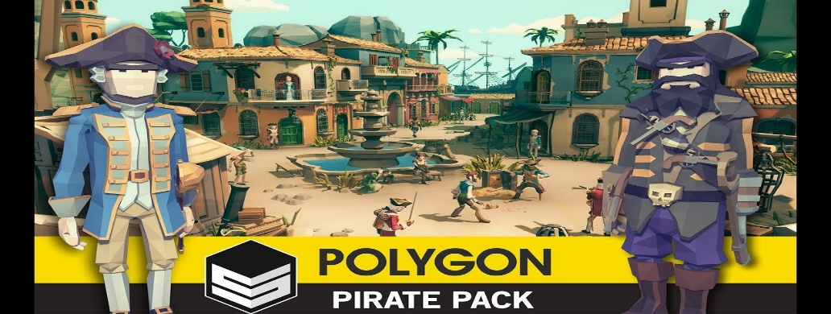

I'm getting another thing of theirs, and have some piratey things I'd make in future so it's not an expense purely for the project don't worry.

## Appendix 2

### Github evidence

<https://github.com/AndrewLetailleur/SailsOfSantiago_UnityProject>

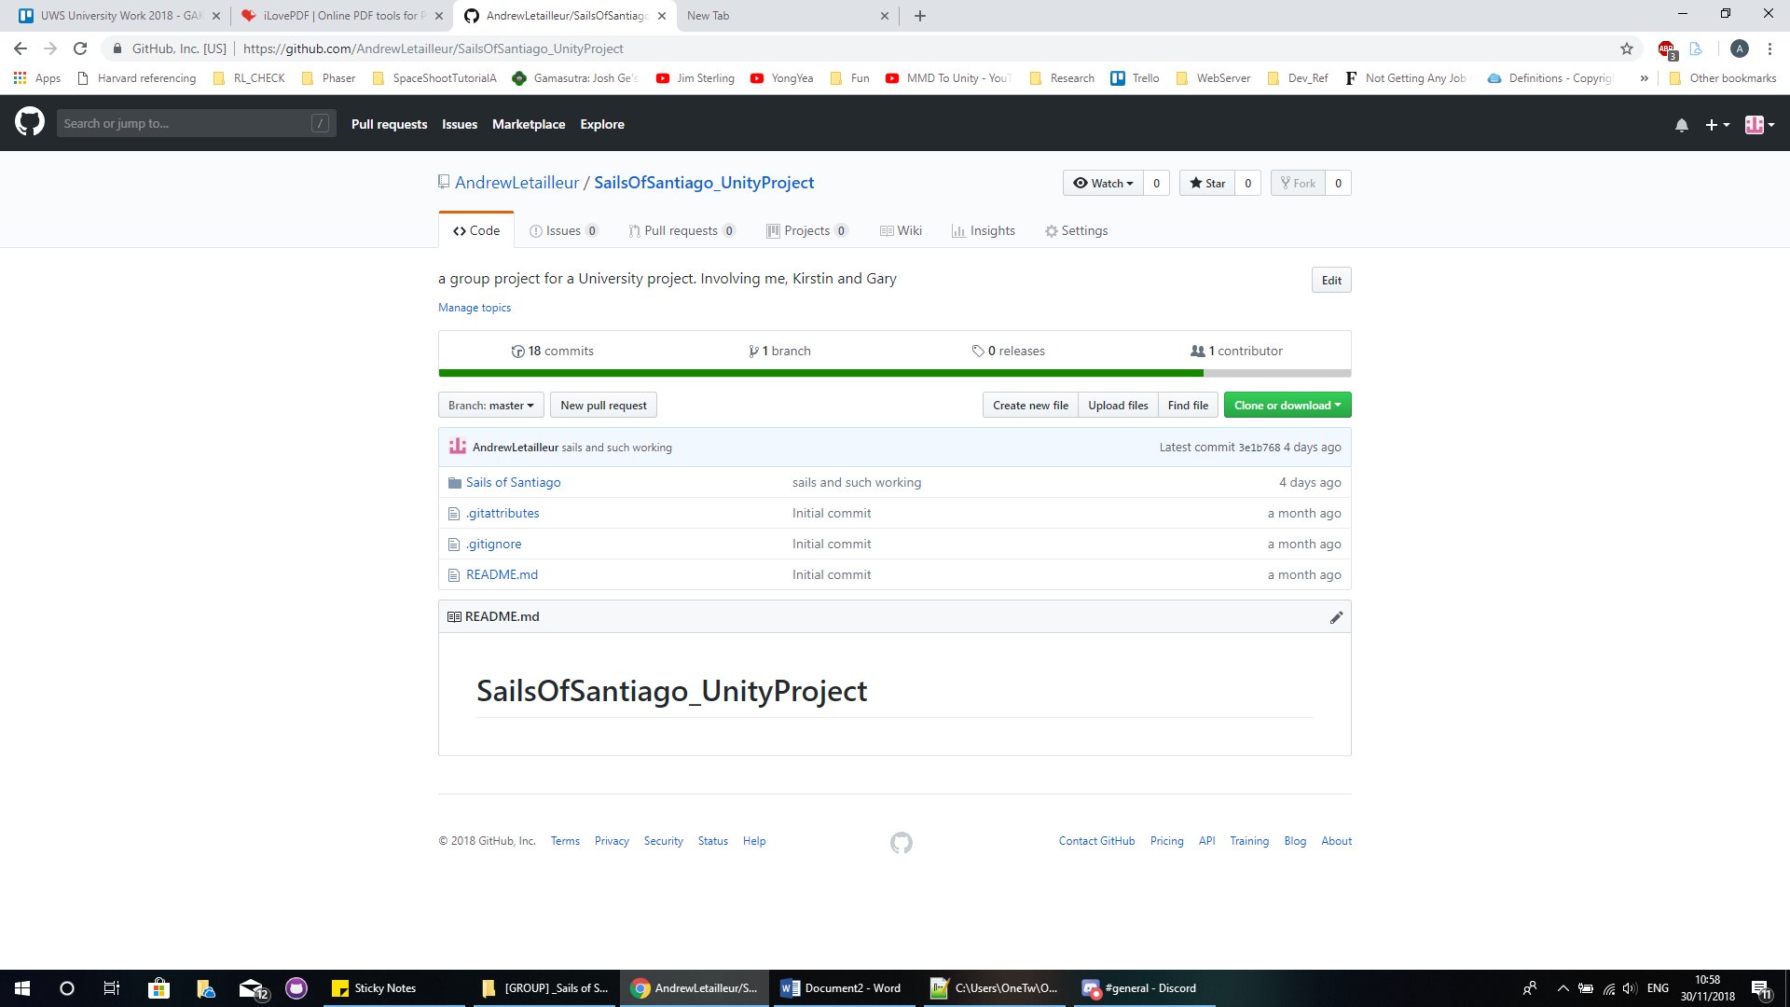

## Appendix 3

### Trello evidence

<https://trello.com/b/sG72VwYw/>

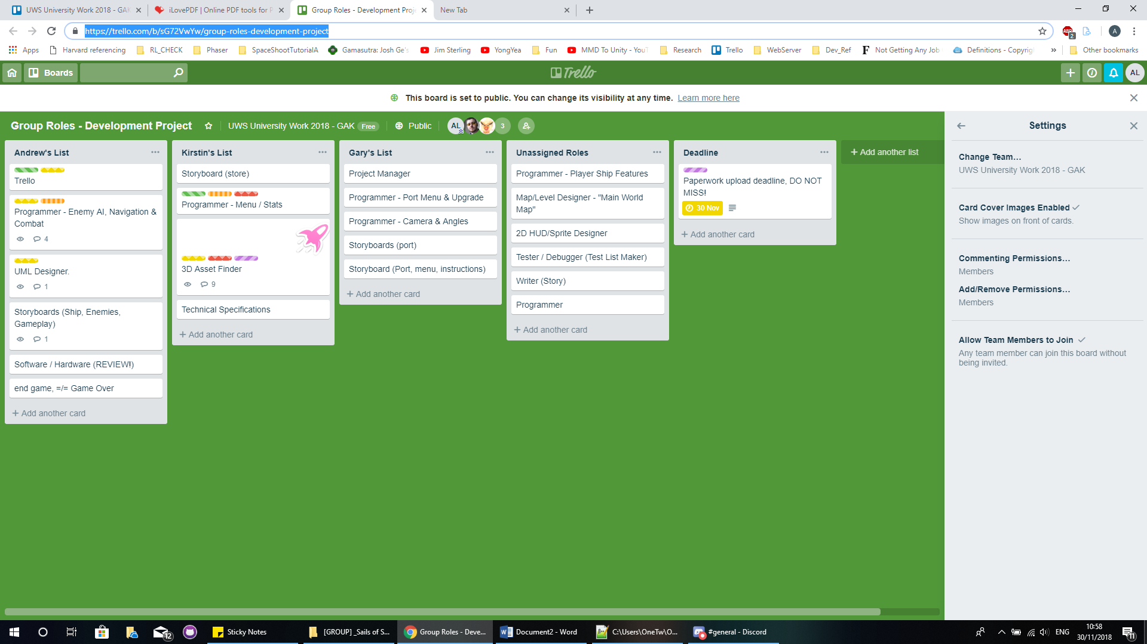

## Appendix 4

### Presentation

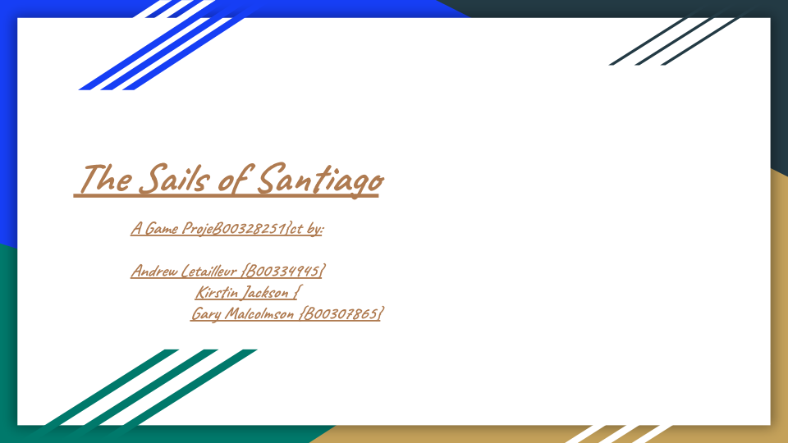

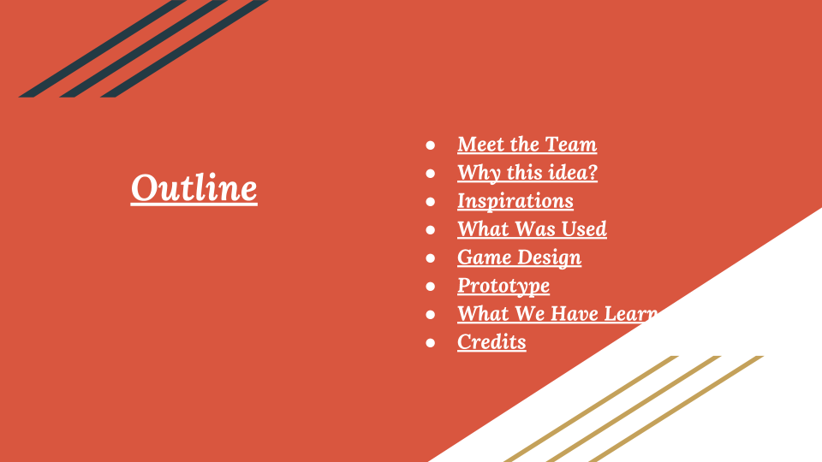



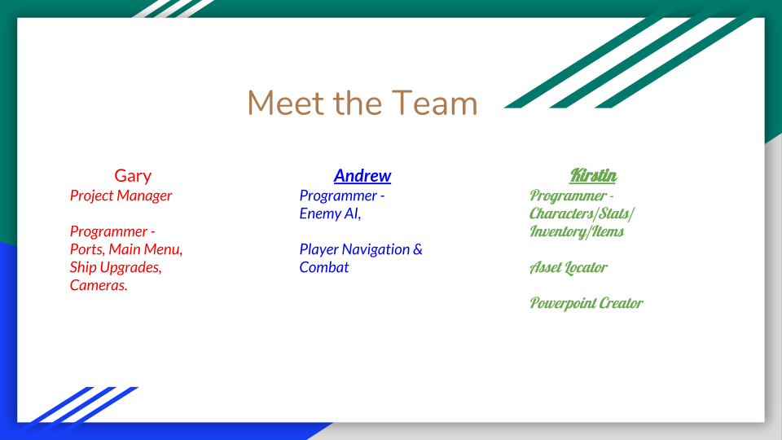



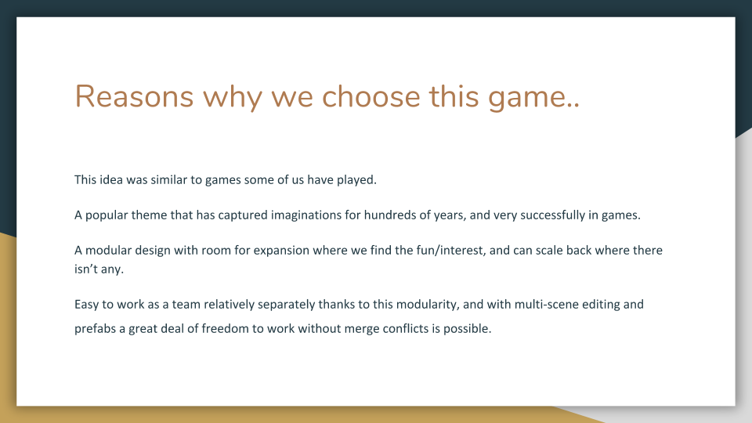



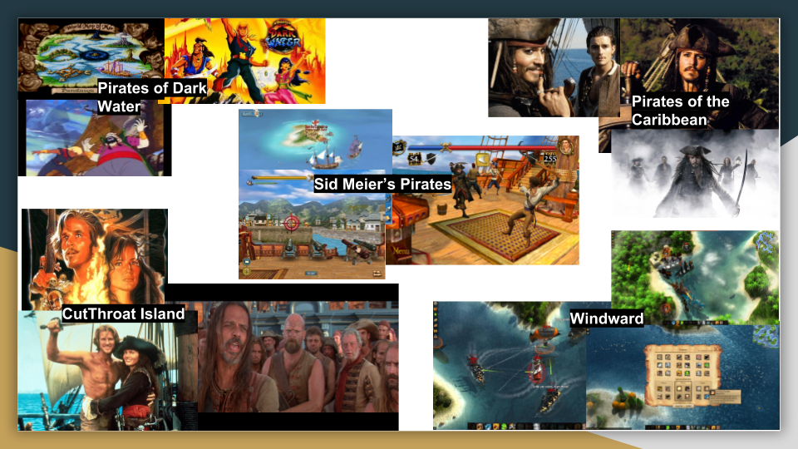

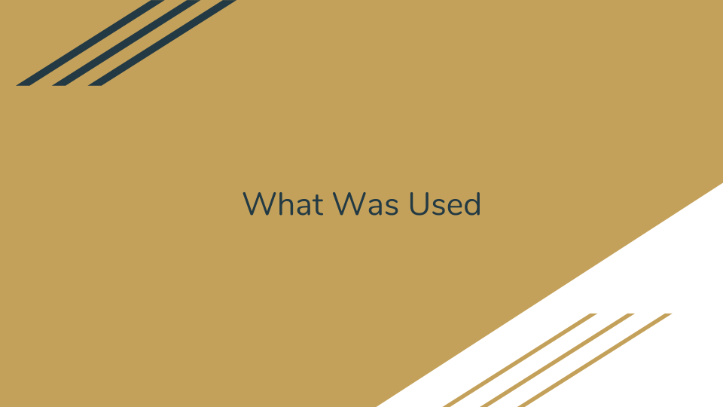

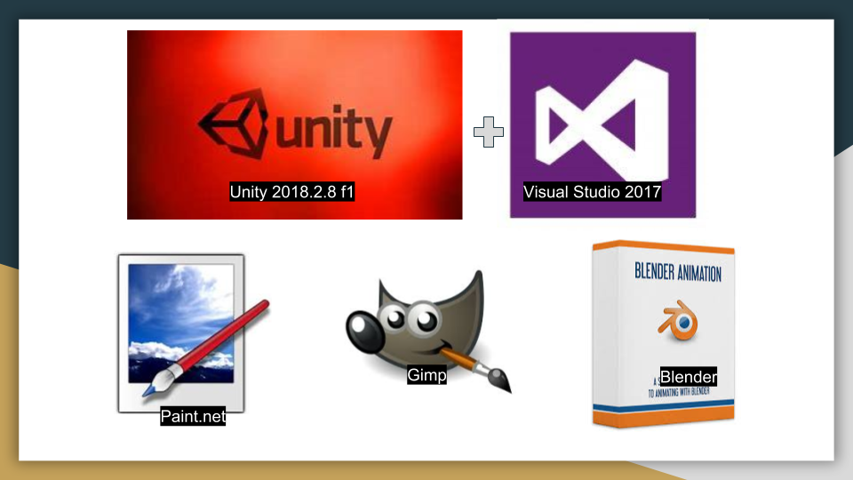

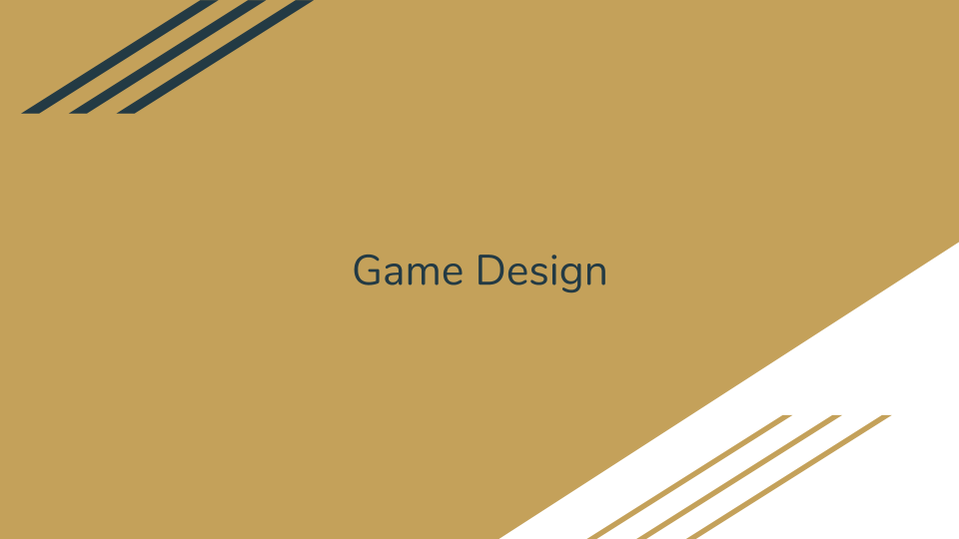

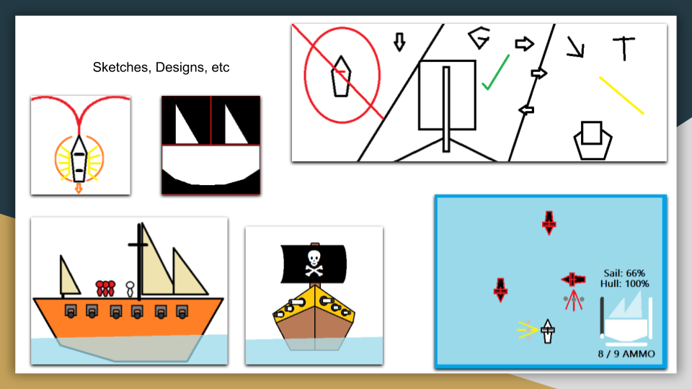

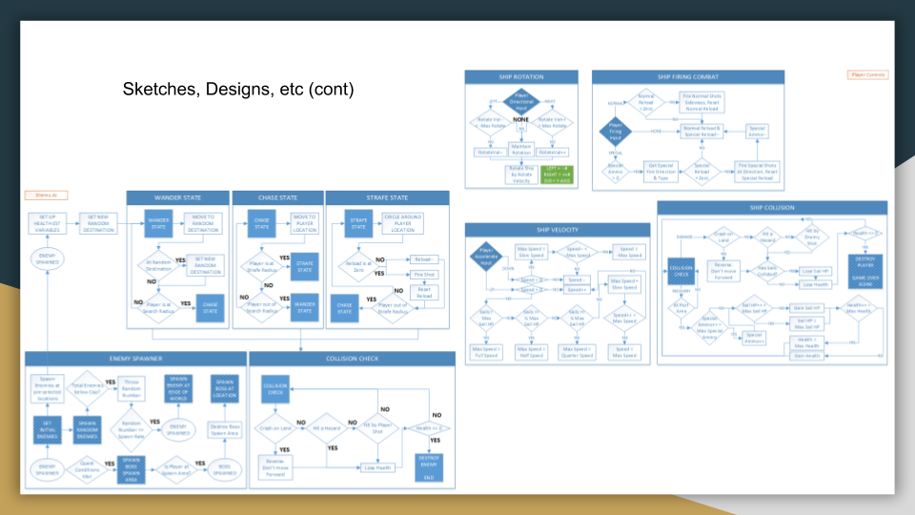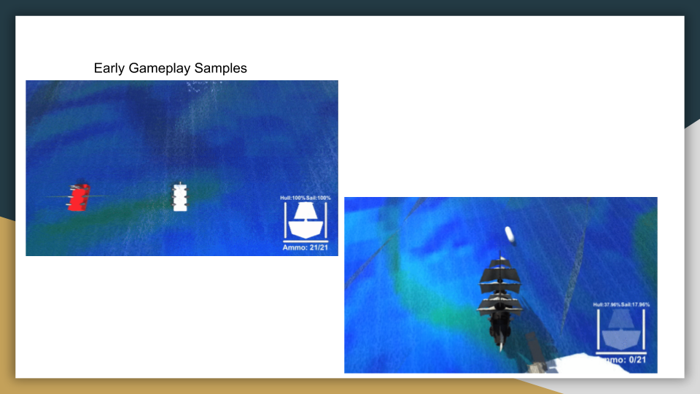

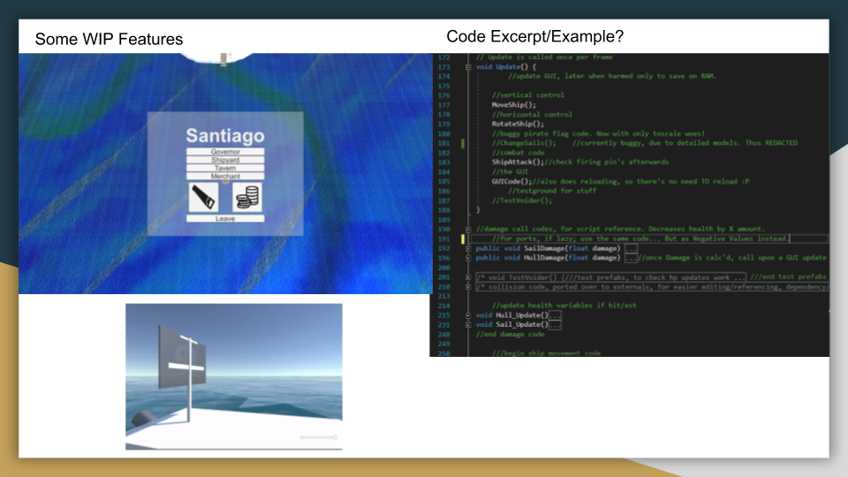

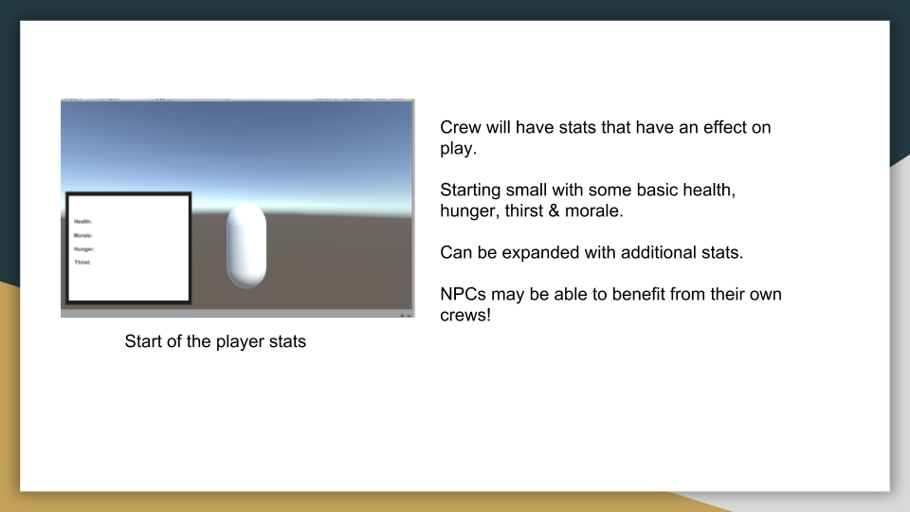

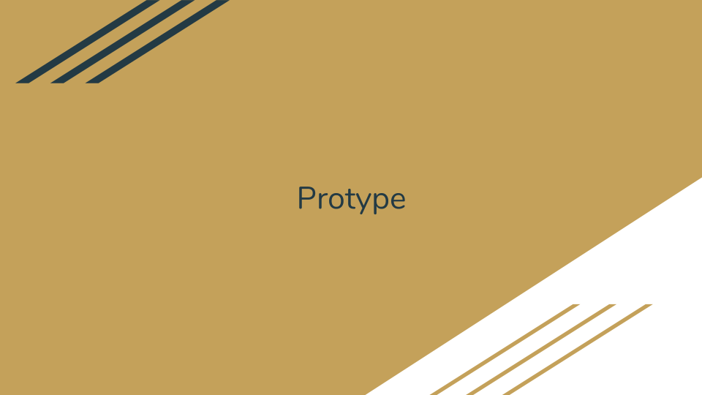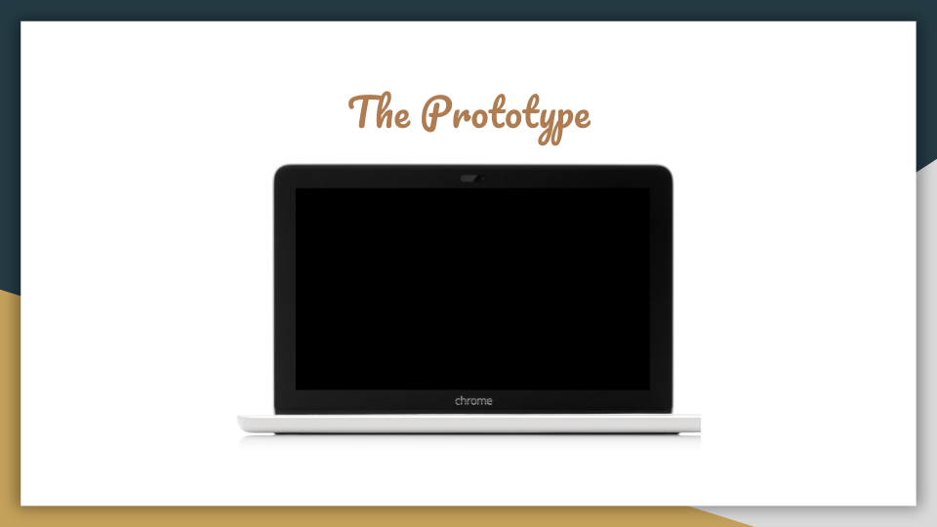

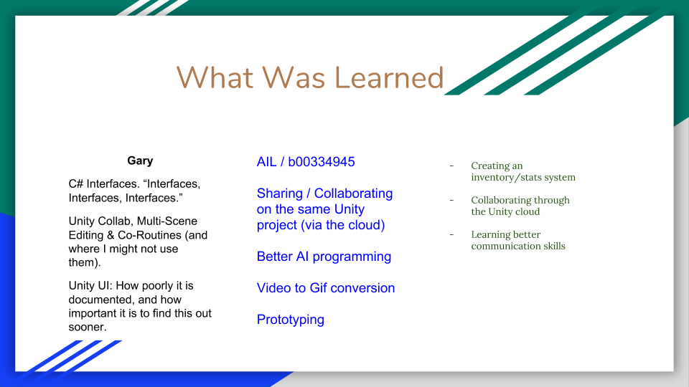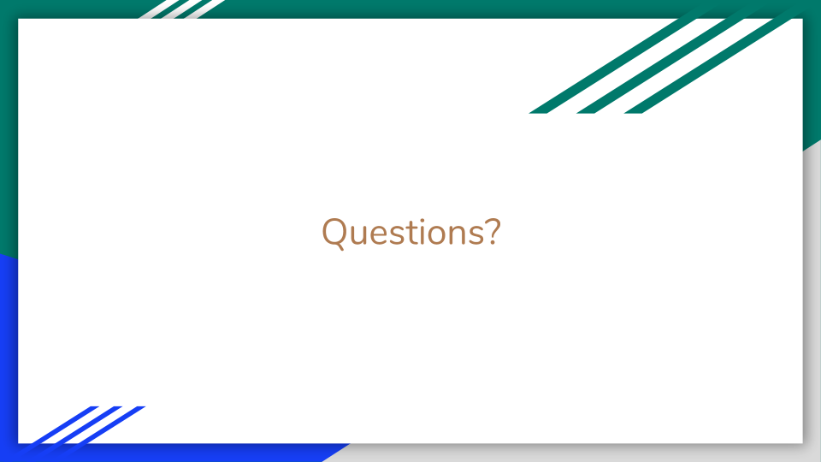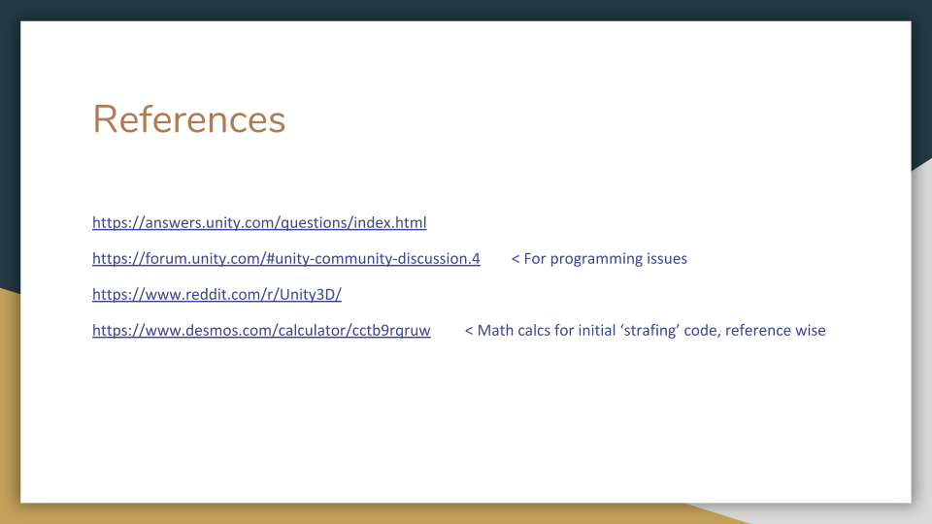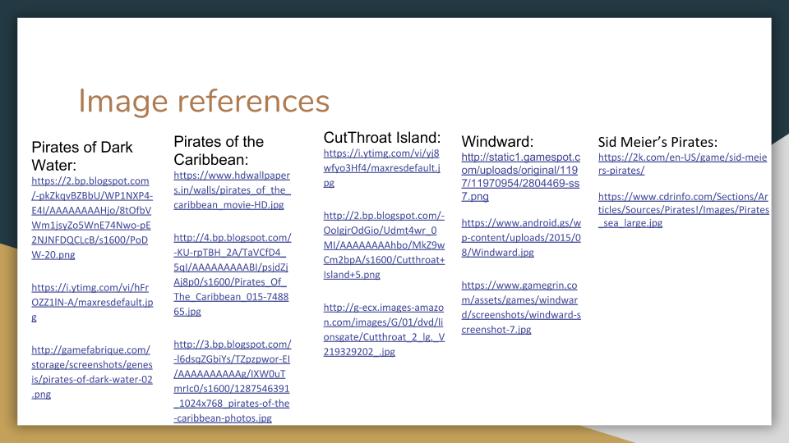

## Appendix 5

### List of Assets Used

# = a General folder. Assets below gen’s are precise assets in folder.

|  |  |  |  |
| --- | --- | --- | --- |
| Asset Name | Author | File Type | Storage (MB) |
| **\_UnityAssetsExt** |  |  |  |
| #Standard Assets | Unity Technologies | Asset Files | 115 MB |
| #NavMeshComponents-2018.2 | Unity Technologies | Asset Files, Script addition (NavMesh) | 6.37 MB |
| **\_Third Party Assets** |  |  |  |
| ColonialShip | Nokobot | Models | 187 MB |
| #Lowpoly paper boats | Rajat Verma | Models, in Files | 3.13 MB |
| USSC Brig Sloop | Joe Censored Games | Models | 59.5 MB |
| #Polygon Pirates | Synty Studios | Models, in Files | 67.5 MB |
|  |  |  |  |
|  |  |  |  |